SUZUKI 650 BURGMAN MOUNTING INSTRUCTIONS

UPPER FRONT: LOWER REAR:
(4) 8mm - 1.25 x 35 bolt (1) 8mm -1.25 x 35 bolt
(1) 8mm -1.25 x 25 bolt (1) 8mm lock washer
(5) 8mm lock washer (1) 8mm flat washer

LOWER FRONT: LOWER REAR:
(4) 8mm - 1.25 x 35 bolt (*) Stock Bolt
(4) 8mm lock washer

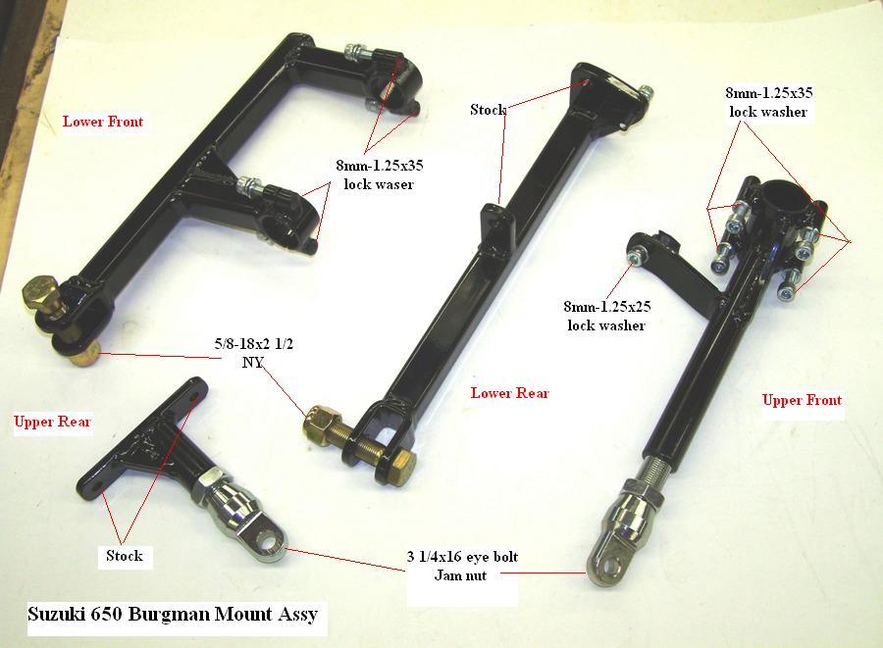

SUZUKI 650 BURGMAN MOUNTING INSTRUCTIONS

- Remove engine access shroud. 6) Remove lower rear fascia (above mud guard).
- Remove lower handlebar fascia. 7) Remove upper rear fascia.
- Remove upper dash. 8) Remove right passenger grab rail.
- Remove lower dash. 9) Remove right rear quarter panel.
- Remove right lower cowl (panel under right foot rest). 10) Remove center stand.

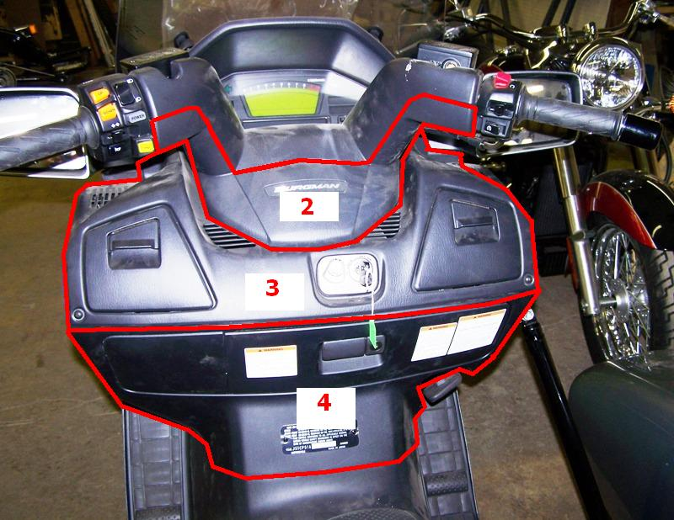

SUZUKI 650 BURGMAN MOUNTING INSTRUCTIONS
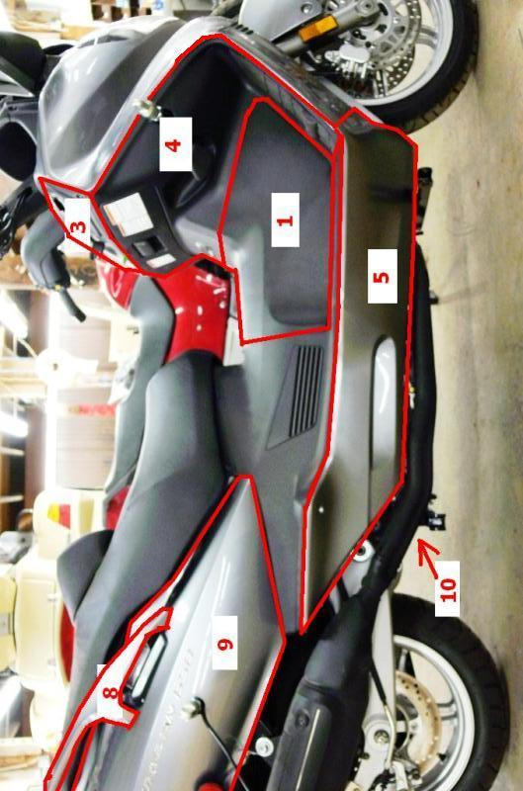

SUZUKI 650 BURGMAN MOUNTING INSTRUCTIONS

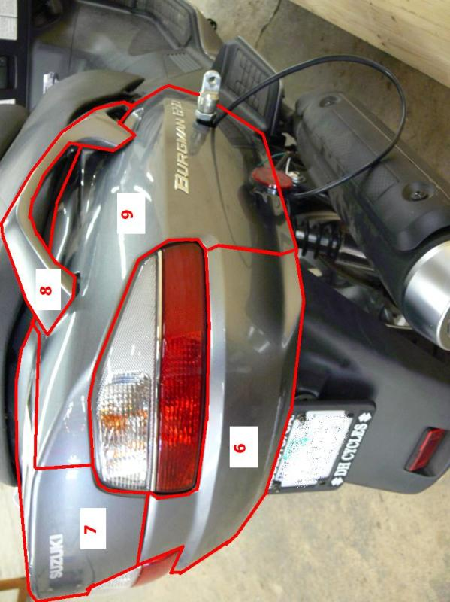
SUZUKI 650 BURGMAN MOUNTING INSTRUCTIONS
- Install upper front mount using (4) 8mm x 35 bolts with lock washers for the clamp and (1) 8mm x 25 bolt for the brake. 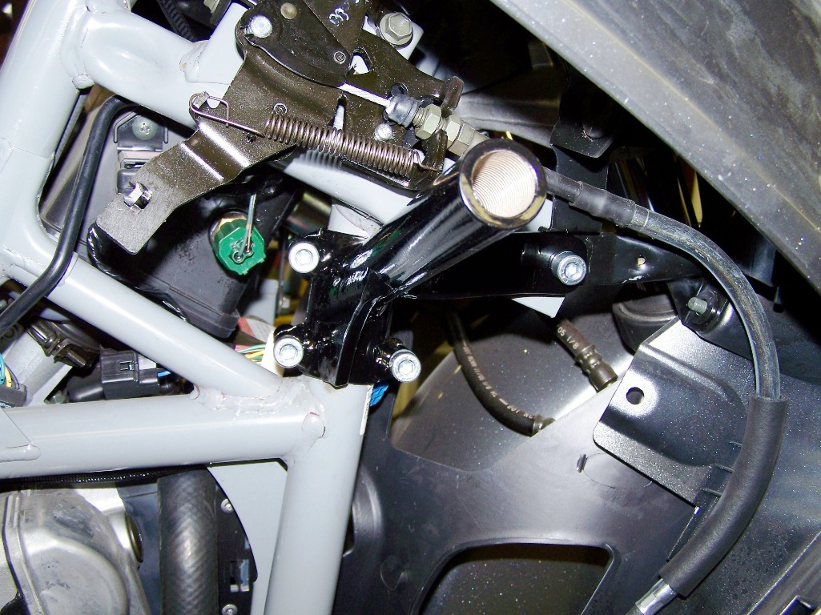
- Install lower front mount using bolts (4) 8mm x 35 bolts with lock washers. Position the mount approx. 1/8” from left lower cowl.
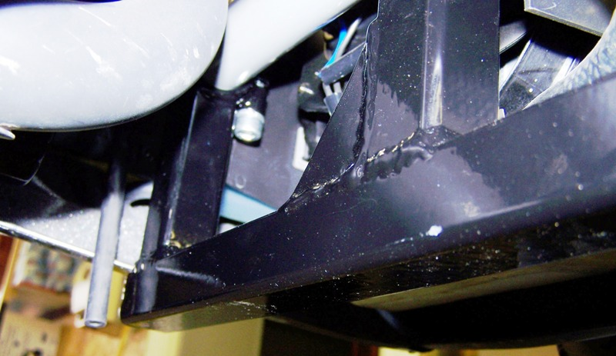

- Install upper rear mount using stock bolts. Be sure to position the mount with the triangular gusset to the left. 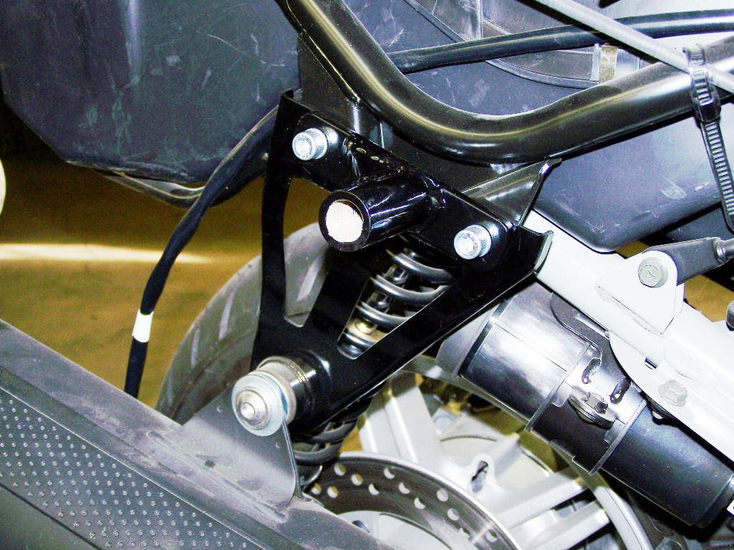

SUZUKI 650 BURGMAN MOUNTING INSTRUCTIONS

- Remove the center stand
- Install lower rear mount on the left side using the stock center stand bolt and (1) 8mm x 35 with washer and lock washer. Then install the stock bolt on the right side.
- Using the supplied templates and the appropriate size hole saw for upper front right mount (2”) and upper rear right mount (1 3/8”). Full size templates are attached.

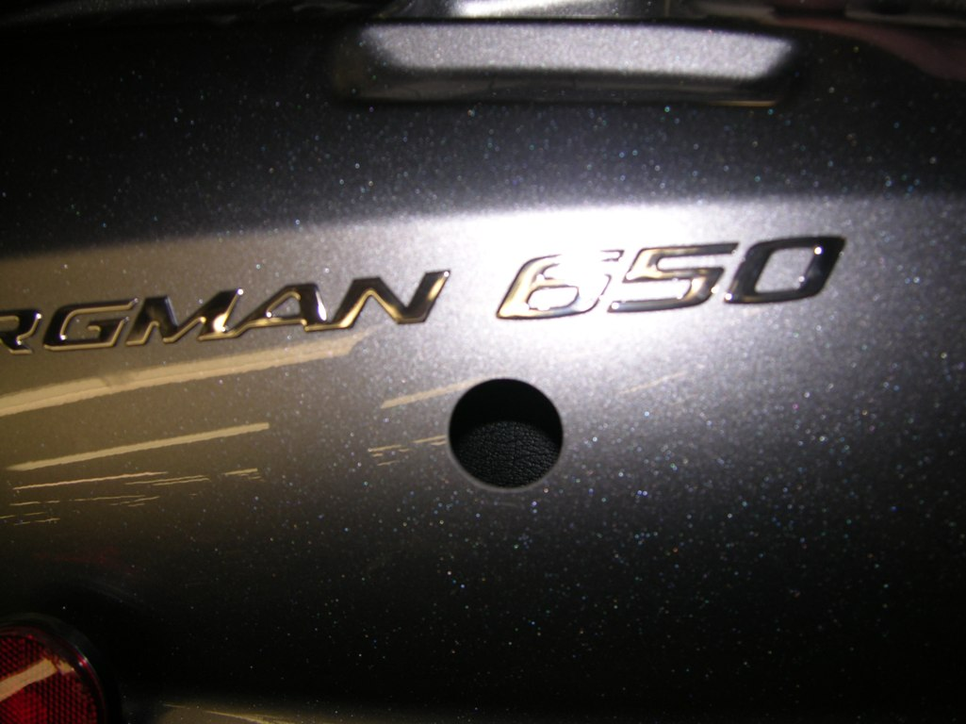

SUZUKI 650 BURGMAN MOUNTING INSTRUCTIONS

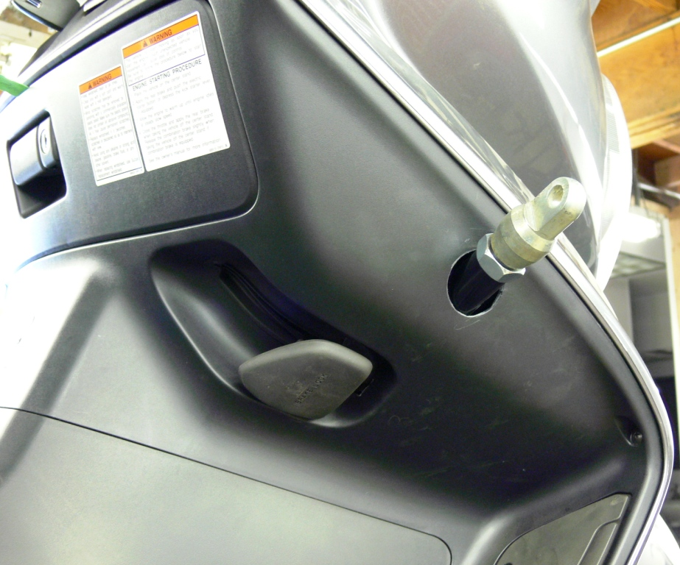

WIRING = BIKE SIDE: WIRING = SIDECAR SIDE:
Black with white stripe = Ground Green = Right turn signal White with black stripe = Brake Red = Brake
Green = Right turn signal Black = Tail light
Gray = Tail light White = Ground

- Access the stock wire harness where it passes near the right side seat hydraulic lift with supplied wire harness.
- Zip tie wire harness to frame and pass under upper rear mount. The sidecar harness will pass through the same hole as the upper rear mount.
- Re-assemble body work in reverse order, starting with the right rear quarter panel.
- Brake line 30” with 90º banjo and quick disconnect for bike side of brake system.

